Part 1: Plot of the MATLAB code

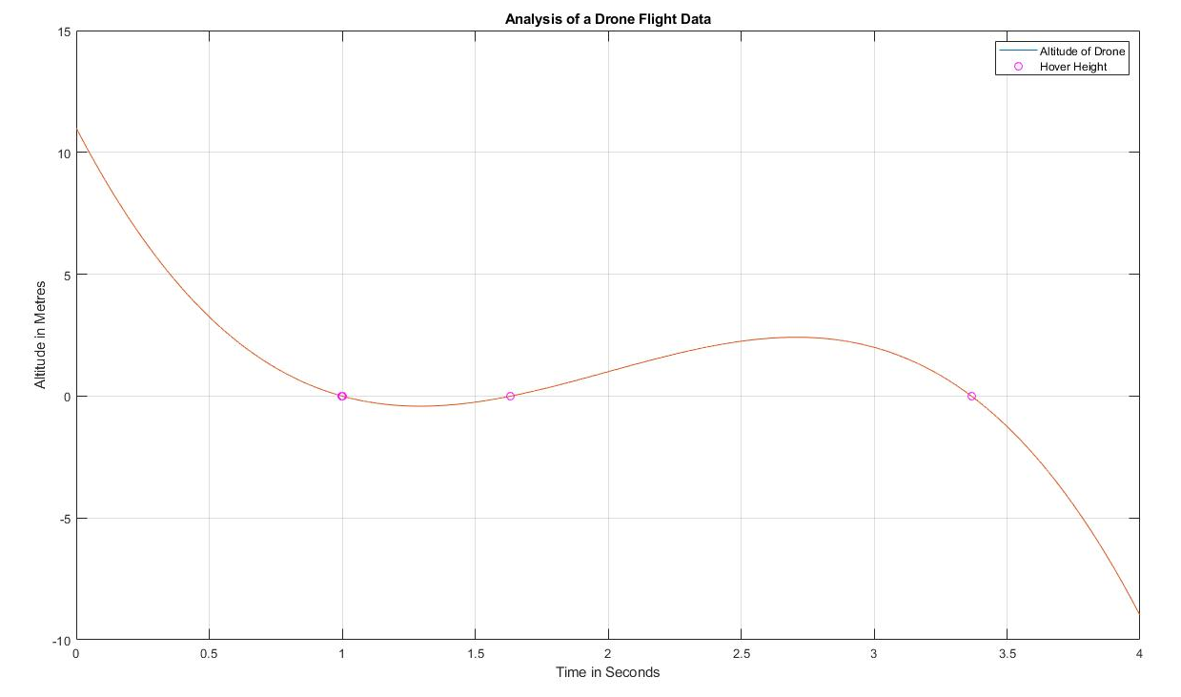

Code:

x=linspace(0,4,100001)

y=(-2).\*((x-2).^3)+(3).\*(x-2)+1

plot(x,y)

grid on

hold on

ylabel('Altitude in Metres')

xlabel('Time in Seconds')

i=find(abs(y)<0.001)

plot(x(i),y(i),'mo')

title('Analysis of a Drone Flight Data')

legend('Altitude of Drone','Hover Height')

Part 2: Engineering Design Process Analysis

Through this lab, I have applied the engineering design process throughout, ranging from assessing the problem to testing and evaluating my solution. During the Devising a Plan Stage, I thought of two ways that I could approach this problem. I knew that an altitude of zero metres meant that I would have to find the x-axis intercepts of the function (or in this case, the time axis intercepts) between the interval of 0 seconds to 4 seconds. I could do this either one of two ways: using the find function or using the roots function. Since during the MATLAB Onramp assignment I remembered that I used the find function, I decided to use the find function because I was more familiar with it. After I was done my code and realized that it was successful (I found the three intercepts), I decided that I want to reevaluate my solution and attempt to code the same problem using the roots function. I used the roots function and it rendered the same result. I was proud of my accomplishment because I was creatively thinking and not just sticking to one solution to a problem. Thus, I felt that I stuck to the engineering design process and embodied the characteristics of an engineer.